Druga gimnazija Sarajevo
International Baccalaureate Middle Years Programme
History

INTERDISCIPLINARY PROJECT
SILENT WITNESSES OF OUR CULTURAL IDENTITY

Word count:702

Student: Teacher:
Alden Pokrklić Emir Ševa

30 January 2015

Stećci are a silent witness of the medieval bosnian culture and the existance of Crkva bosanska. „Stone sleepers“, how Mak Dizdar called them, are massive thombstones that patronized the life work of bogumili. But some people deny that and claim that they are just a way of art expression. They are located all over BiH, except for Posavina and Bosanska Krajina. The oldest Stećak is from the second partof the XII century, but the one in a shape of a coffin is from the XIV century. Necrpolis, are groups of Stećci, that can be devoted toone specific family, or all citizens from one medievil village. The meaning of the word is the city of the dead and it can contain hundreds of Stećci. If we look at the estetic elements, writings of famous historic persons the most significant is Radmilja in Vidovo field. We also have one in Bitunje, a village southeast of Stolac and in Šabići.
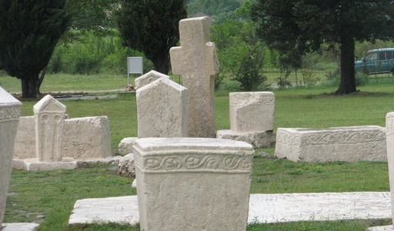
The followers of Crkva bosanska have always been considered heretics and unmoral dualists by Vatican and the pope. They weren’t accepted by the rim catholic or Orthodox Church. They were called names like baboons. The fact that they connected evil with everything that is material, they were considered dualists and because they believed in the constant fight of good and evil. Kulin ban had always defended this organization because he believed in the fundamental right of a man to choose his religion and not only did he provide support for his people, he provided support for bogumili from Raška that had been vanquished by Stefan Nemanja. Crkva bosanska found an inspiration in religions of Egypt and Greece and they incorporated those beliefs with theirs. They believed that a man has to possess wisdom or “sofia” to find internal peace. Because they believed in the fact that everything that is spiritual will bring man joy and happiness, they were very much educated individuals. They were also brave warriors and patriots. “If I leave my bones in some other land, I would steal dream of Bosnia.” But the real purpose of these monuments was not to brag about their personal achievements, but to spread their beliefs and attitudes on other individuals that maybe haven’t already found spiritual peace and haven’t chosen their religion yet. One more thing is that they often referred to the fact that life passes us by without us even noticing and that is very important to leave something for the upcoming generations like they did. “You that pass, pass in peace and don’t talk about our sins. That is without purpose. Our days have been counted long ago. Our words are used, our sins mist.” This is one of the writings.

Stećak can be laid down on the ground or standing upwards, but most of them are laid down and they can be in shape of a panel, sarcophagus or coffin. We have also Stećci that are shapeless. The artistic value of these tombstones is in the carvings and engravings on them. The symbols can be social or religious. Social ones are coats of arms and they were most commonly dedicated to the lower noble class. Most of them are made like the ones of the western European heraldic, but some of them are made with a motive of a sword and shield. Also we have figural expressions of the deceased himself, or some village competitions that involved spear throwing and such because we know that they were great warriors. Also many undefined decorations can be found like strange shapes and lines.
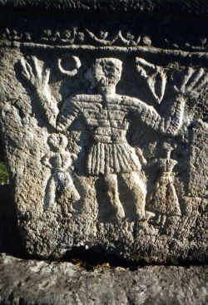
These tombstones have great importance for exploring the history of medieval Bosnia because they contain records of some significant historic figures of that time. The first writing about Stećci is from 1530 by a Slovenian, Benedikt Kuripešić. Many have tried to deny the connection between bogumili and these tombstones, but Arthur Evans, a worldwide renowned archeologist had proven the correspondence between these two and sealed it in European historiography. Also they represent and defend the identity of our country even in times like the middle ages. In the sense of linguistic importance, many great writers like Mak Dizdar have found inspiration to write their work in these monuments.
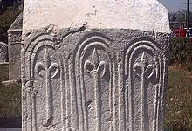

Bibliography
„Bosanski web portal u Švicarskoj“, 3 November 2008
< http://www.camo.ch/blago-bih/stecci-u-bih/ > 30 January 2015

“Prometej” 8 November 2011
< http://www.prometej.ba/index.php/home-6/298-stecci-zajednicka-bastina-bosanskohercegovackih-naroda > 30 January 2015

„Hercegovina info“ < http://www.hercegovina.info/img/repository/2010/05/web_image/foto-radimlja-stolac.jpg > 31 July 2013 Radmilja necropolis
Bosanski web portal u Švicarskoj“ < http://www.camo.ch/blago-bih/stecci-u-bih/ > , 3 Novembar 2008 Quote about love of bogumili to Bosnia, free translation
Bosanski web portal u Švicarskoj“ < http://www.camo.ch/blago-bih/stecci-u-bih/ > , 3 Novembar 2008 Quote about the gtransience of life, free translation
„Drmaj.ba“, < http://www.kalesijski.com/wp-content/uploads/2013/01/kulin-ban-300x200.jpg > date unknown, Portrait of Kulin ban, human rights and Crkva bosanska defender
„Sveučilište u Mostaru“ < https://encrypted-tbn1.gstatic.com/images?q=tbn:ANd9GcQVNSY5iCXso65O6y19eAiEx7pU6gL9Ezidpjj-q3uSVi-LfnkRXo-I3DI >, date unknown, The decorations on tombstones
„Bosanski web portal u Švicarskoj“ < https://encrypted-tbn1.gstatic.com/images?q=tbn:ANd9GcQcc_QFuPMKVfjKVB-cYGESFD1A3YenAxzIrTI4rdU5L0FBQwx1l0JN1fM >, 3 November 2008, another Stećak

